**Why was Zionism established in the nineteenth century?**

**Lesson 2**

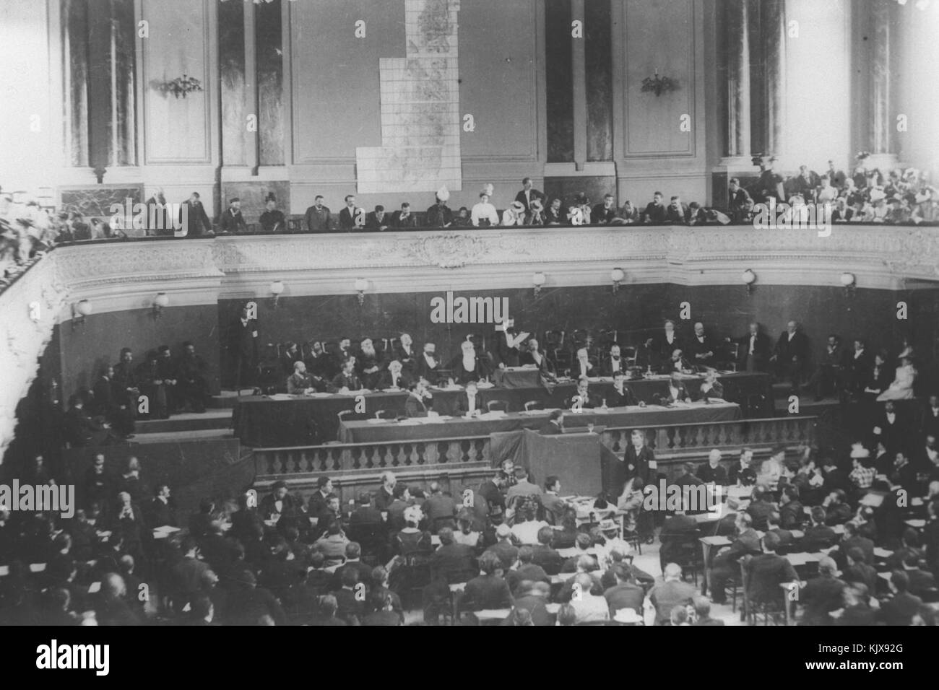

**By the end of this lesson, you should be able to:**

Define Zionism

Explain why Zionism was established in the nineteenth century

Evaluate the support and opposition to Zionism at this time

**Keywords**

Jewish

Antisemitism

Judaism

Pogrom

Zionism

**Knowledge check!**

How would you define the following: Jewish, Judaism, antisemitism?

Have you studied any examples of antisemitism before?

**A brief history of antisemitism**

Antisemitism: **hostility, prejudice or discrimination against someone because they are Jewish**

Sadly there is a long history of antisemitism in Britain and across the world. The earliest examples go back to the days of the Bible

The first records of Jews in England date back to around 1070, when Jews were invited to settle in England by William the Conqueror. But when Jews arrived in England, they were treated appallingly. For example, laws passed in the thirteenth century meant that Jews had to wear a **badge of shame** to identify them as Jewish, and in 1290 Jews were **banished from England** altogether. They were only allowed to return in 1656

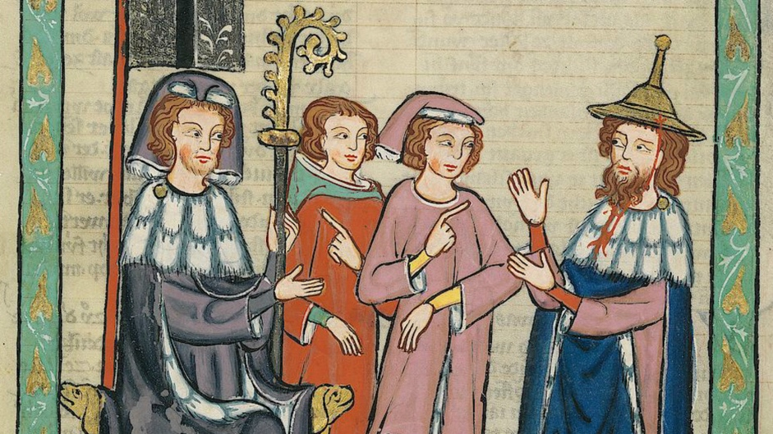

Medieval clothing laws

Antisemitism was present across Europe too. Jews were forced to live in **Jewish-only** **ghettos** and often they were **not allowed to own land**. In 1492, Jews were banished from Spain

In the 1800s and early 1900s, a wave of **pogroms** (violent attacks on Jews) swept across the Russian Empire. During the Kishinev pogrom of 1903, for example, 49 Jews were killed

This long history of antisemitism provides important context for understanding the emergence of Zionism in the nineteenth century



In York in 1190, the city’s entire Jewish population was trapped inside the tower of York Castle and massacred

**Question**

Were you already aware of this long history of antisemitism or has it surprised you?

**The emergence of Zionism**

It was in this context of antisemitism that some Jews began calling for their own Jewish state in the mid-late 1800s – Zionism was born!

Before this, the Jewish community had been diasporic. This meant that Jews lived across the world but they retained a connection to the land of Palestine-Israel, which they were expelled from between 8 BCE and 6 BCE (around 2000 years ago)

[**https://www.iijg.org/wp-content/uploads/2018/01/LeitenbergCrystall-JewishPopulationsMaps-Report-updated.pdf**](https://www.iijg.org/wp-content/uploads/2018/01/LeitenbergCrystall-JewishPopulationsMaps-Report-updated.pdf)

Those involved with the Zionist movement were also inspired by other **nationalist movements** at this time, for example in the USA and France

Alaska and Uganda were considered as territories for a future Jewish state, but **Palestine-Israel** (then home to the Palestinians, as we learnt in Lesson 1) was the most popular choice

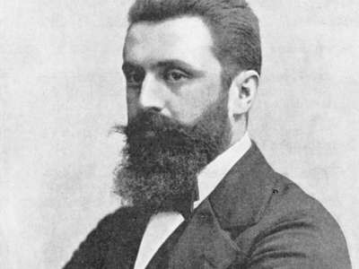

Theodor Herzl is considered the **founder of modern Zionism**. In 1897, Herzl organised the First Zionist Congress in Basle, Switzerland. This was an important point in the development of the Zionist movement

**Why ‘Zion’-ism?**

Zion is an alternative name for Jerusalem. Can you remember why Jerusalem is **significant** to Jews? Look back at your notes from Lesson 1 to answer this question

**Activity**

Write a paragraph explaining the causes of the emergence of Zionism in the nineteenth century

**Question**

Is Jewish and Zionist the same thing? Why not?

**Support and opposition to Zionism in the nineteenth century**

**Questions**

Which side do you find most convincing? What do both sides have in common?

**Check your knowledge!**

What is Zionism?

Write down to reasons why the Zionist movement was established in the nineteenth century

**Extension activity**

If you were a) Jewish b) Palestinian in the nineteenth century, how would you have felt about Zionism? Write three sentences from each perspective